NGO: Banwasi Seva Ashram
Location: Uttar Pradesh
Award: $10,000
Category: Skilling/Youth Employment

Banwasi Seva Ashram, an NGO working on Gandhian principles has been working in the Sonbhadra District of Uttar Pradesh since 1954. It is one of the most backward districts of India, in spite of having a lot of natural resources. The problem is also compounded by the fact that young people migrate to the cities in the absence of adequate work opportunities for their survival. There is dire need for a new set training to channelize energies of the youth towards social transformation and protect them from falling prey to evils such as addictions, violence and trafficking.

With more than fifty years of experience addressing basic problems faced by the tribal and scheduled class forest dwelling community, the organization recognized that youth skilling is vital to retain the youths in the development of the local communities. With support from IDS, they have targeted 240 school dropout youths and girls/women for vocational training. For the initial period, they were able to train 154 youths (15 men, 149 women) with the following vocational training:
- Fruit and Vegetable Preservation training was organized for 40 high 10th class students and 27 girls/women. They learned preservation techniques and pickle making for fruits such as mangoes, jackfruit, Bael, Amala laddu, Murabba, etc and learnt how to price them for selling in the market.
- Mushroom cultivation training was organized at 5 village cluster levels with one day training in group and 2 days hand holding support was given to start cultivation at their home. Total 55 girls/women got trained. This spawned and started mushroom cultivation small scale industries in these villages.
- Dress Making training was organized in collaboration for 20 SC/ST girls.
- Basic computer class were organized for male youths teaching the MS office programs
These vocational trainings have provided livelihood in the community. For example, mushroom cultivation is fetching 2 to 3 thousand rupees/month and girls/women can sell pickles at 100 rupees/Kg. Such micro level vocational training is helping the community with steady level of income and improving their livelihoods while grounding the youths to feel confident about themselves.

Success Stories:

Savita Devi got training in pickle making. She initially prepared pickle for her home, but give neighbors to test the pickle. She immediately got orders from 10 families and made 50 kgs of mango and Jackfruit pickles for them.

Mrs. Champa Got trained in stitching and dress making; first time she learnt stitching machine. After the training, she started making Salvar Kurta, petticoat, blouses etc. She earns close to 1000 rupees each month that is now supplementing the family income while give her independence and dignity to be self-sufficient.

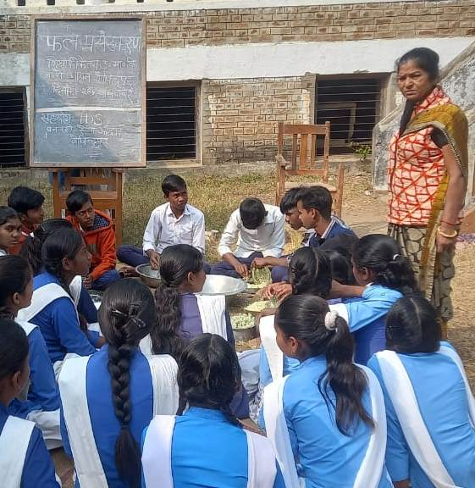

Youths learning Vegetable/Fruit preservation after school

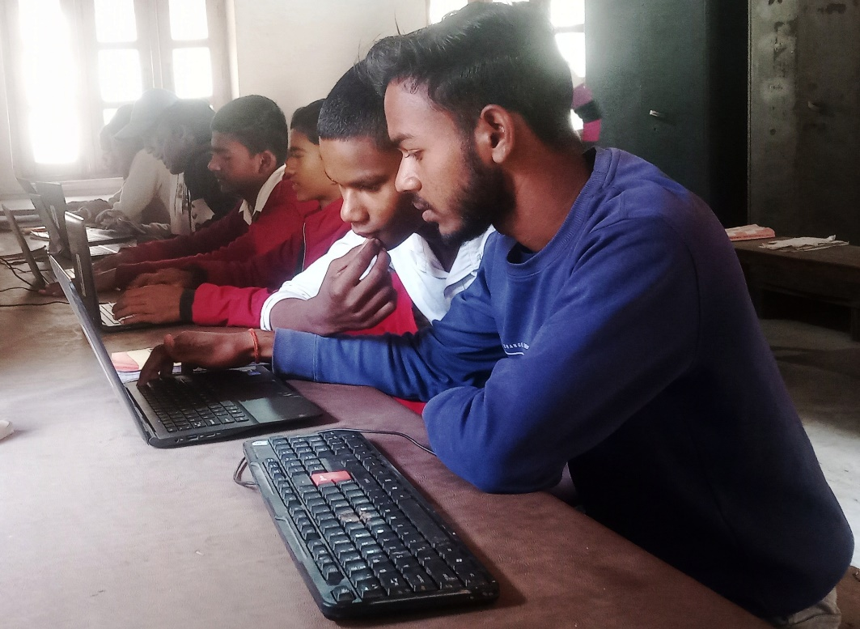

Youths getting computer training

